**DTR ONBOARDING**

When you see a user has come up with a DTR onboarding request, please perform the below steps:

1. Go to the issue under [DTR-Issue-track](https://github.hpe.com/DockerHub/DTR-Issue-Track/issues) and assign the issue to your name by selecting your name under the Assignees section.

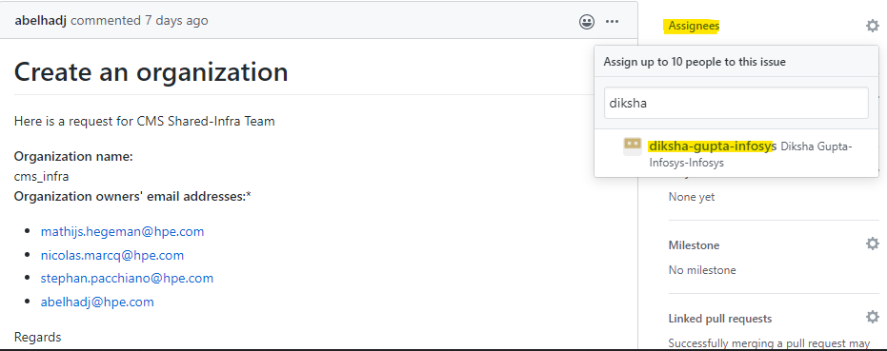

1. The organization name must not have any spaces, special characters, url encoded names, or uppercase characters. Also, check if the org name is not already present by checking in DTR. If the org name does not suffice these criteria, then comment on the issue and ask the user to change the organization name.

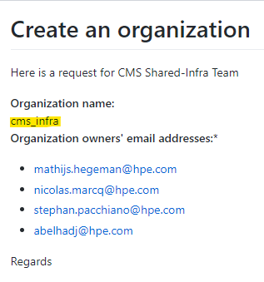

1. Check if the user names given in the request are available in DTR users list. If not present the users whose name was not available has to login at least once to DTR using SSO. This can be commented in the issue. Please check this [issue](https://github.hpe.com/DockerHub/DTR-Issue-Track/issues/735) for reference.
2. Log into Ansible tower using SAML
3. Under Templates, start a DTR-onboarding job by clicking on the icon on the right of the DTR-onboarding template as highlighted below.

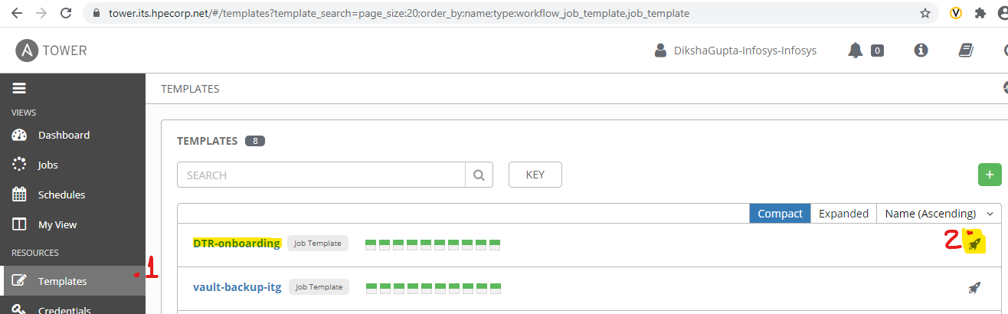

1. Once the template opens, add the name of the organization as specified in the issue (refer image under step II) under ORG_NAME and add the email id (or email ids separated by comma ‘,’) under ORG_ADMINS_LIST. Do not make any changes to the rest of the fields. Run the playbook by clicking on NEXT.

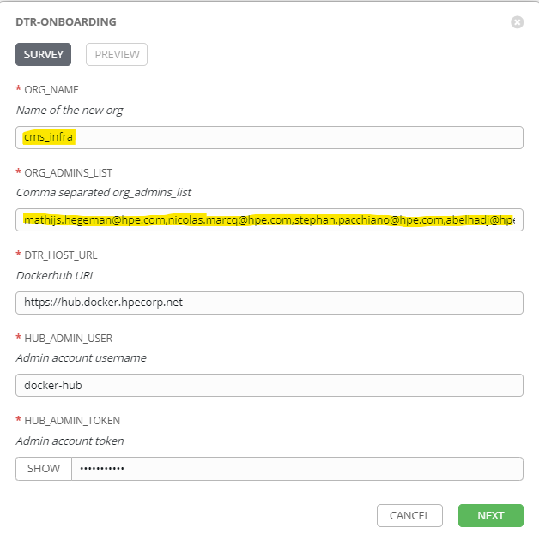

1. If the playbook runs
   1. **Successfully:** Close and comment on the issue that the requested organization (add hyperlink of the DTR organization) has been created in DTR and ask the user to verify if it is as expected. Also, ask the user to try exercising their access by creating repositories, teams and pushing contents and redirected them to the [wiki](https://github.hpe.com/DockerHub/dockerhub-docs/wiki) for any further information. Refer [this](https://github.hpe.com/DockerHub/DTR-Issue-Track/issues/752#issuecomment-1223844) for closing comments reference.
   2. **Unsuccessfully:** Look for the error with which the playbook failed and notify the same to the user and if any changes are required, comment on the issue and ask them to make necessary changes. Once the changes are made as per the ask, repeat steps II to VI.

